|  |  |  |  |  |
| --- | --- | --- | --- | --- |
| |  |  | | --- | --- | | League  Info Server | Image result for football league cup | | Image result for football kick | Image result for football batches | |
| Documentation  Covers Architecture, API Specification using Swagger, Cross Browser & Device UI Testing, UI Unit Testing, UI Automated Testing, Security Testing, Service Unit & Integration Testing, API Performance Testing, Jenkins Pipeline setup, Tech stack used, Deployment structure, Code structure |

Table of Contents

Accessing the Service 3

Accessing the API from Swagger 4

Architecture 5

Cross Browser / Device Testing 6

Setting up & Running the solution locally 7

Pre-requisites 7

Setup Steps 7

UI Unit Tests – Jest, Enzyme 8

UI Automated Testing - Selenium 9

Security Testing – ZA Proxy 10

Service Unit Testing – JUnit & Mockito 11

Service Integration Testing - RESTAssured 12

API Performance Testing - JMeter 13

Jenkins Pipeline Setup 14

Code Package Structure 15

Service Code Package Structure 16

Deployment Structure 17

# Accessing the Service

You can access the service from this URL: <http://13.58.209.5:8080>



# Accessing the API from Swagger

You can also access the core API via swagger using this URL: <http://13.58.209.5:8080/v1/swagger-ui.html>

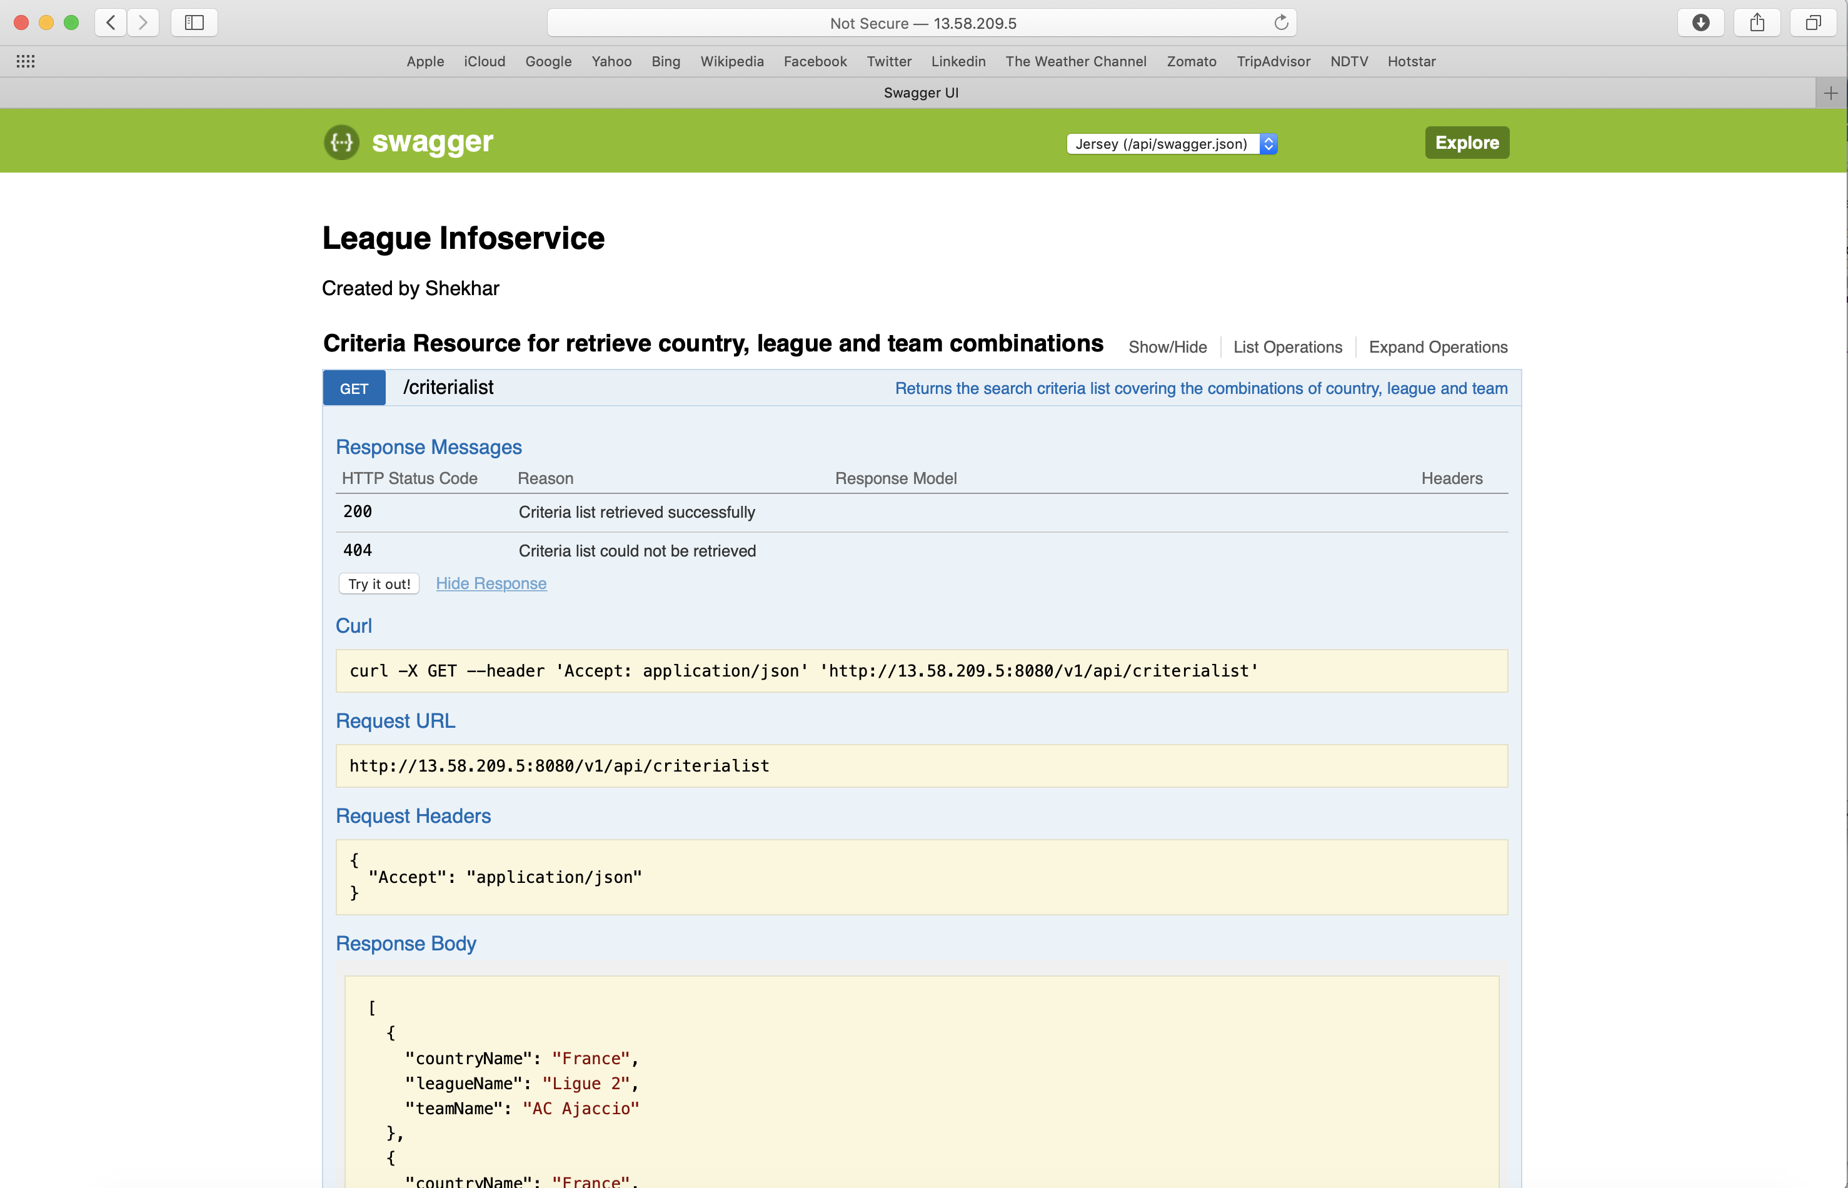

# Architecture

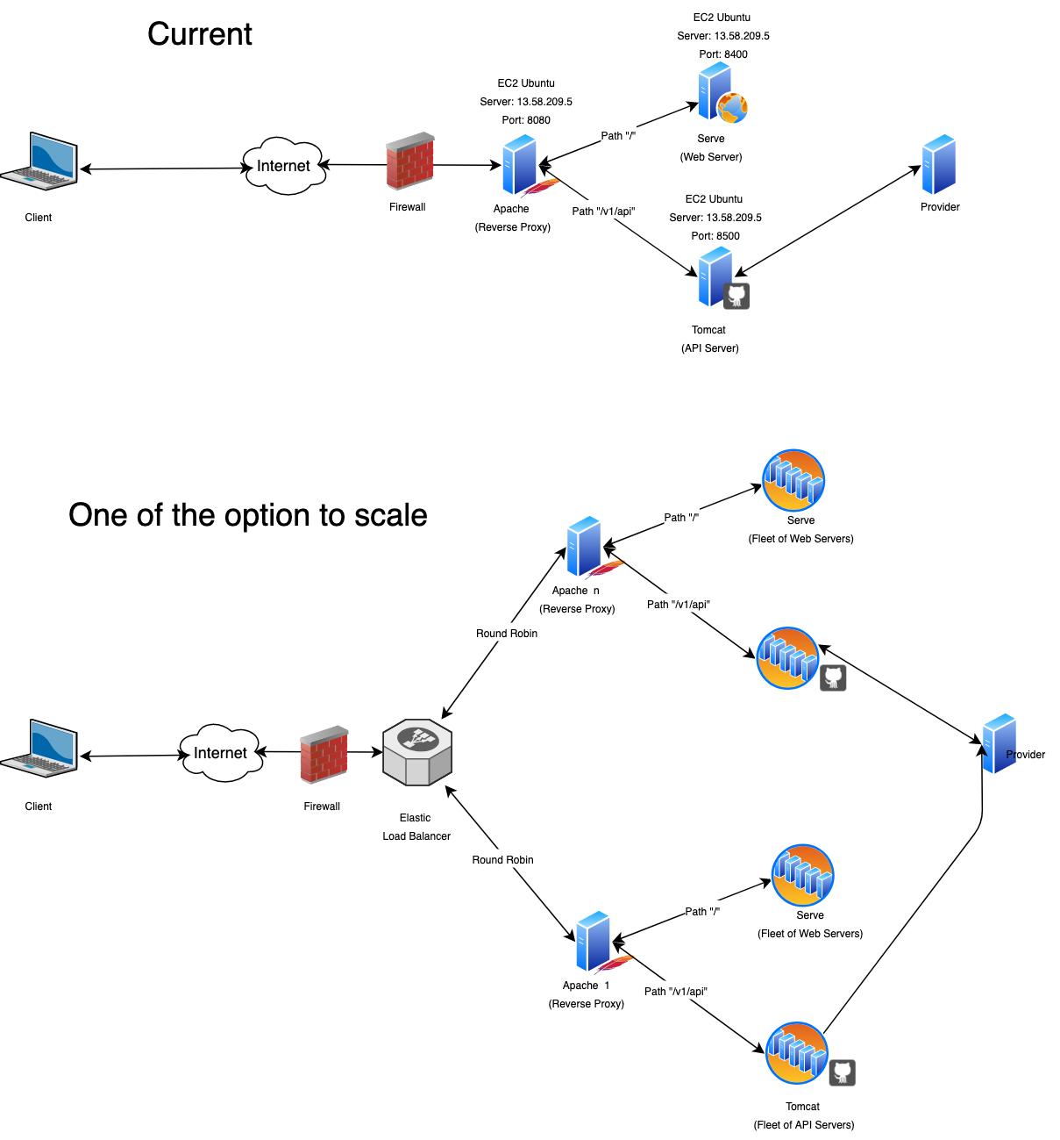

Note: Other options can be discussed based on Use Cases / NFR / Budget / Different or extended Technology Stacks / Cloud services

# Cross Browser / Device Testing

Tested the solution in the following browsers & Devices (some of them are listed below): Chrome, Safari, Firefox, Edge, IPhone, IPad, Android

|  |  |
| --- | --- |
| **Safari** | **Chrome** |
|  |  |
| **Firefox** | **IPad Air** |
|  |  |
| **IPhone 6** | **IPhone XR** |
|  |  |

# Setting up & Running the solution locally

## Pre-requisites

* Install Java 8
* Install node.js (v10.16.1) and npm (v6.9.0)
* Install serve globally (npm install -g serve)
* Install JMeter (Optional)

## Setup Steps

1. Check out the code from github (git clone <https://github.com/siyer70/leagueinfoserver>)
2. Build the code with the command on the root directory of checked out folder: “**jenkins/scripts/build.sh PROD 1.0**”
3. Start the services: **bin/start.sh**
4. You can also stop the services by using: **bin/stop.sh**
5. Check the status of the service: **bin/status.sh**
   * Status should be running
   * UI code runs in 8400 port of localhost
   * Service runs in 8500 port of localhost
   * So, you can access the app using url: <http://localhost:8400/>
   * And access the API service using the swagger url: <http://localhost:8500/v1/swagger-ui.html>

# UI Unit Tests – Jest, Enzyme

UI Unit tests along with coverage:

Tech stack Used: Jest, Enzyme, Fetch-reply-with

Alternatives: Mocha, Chai, Enzyme, Fake-Fetch

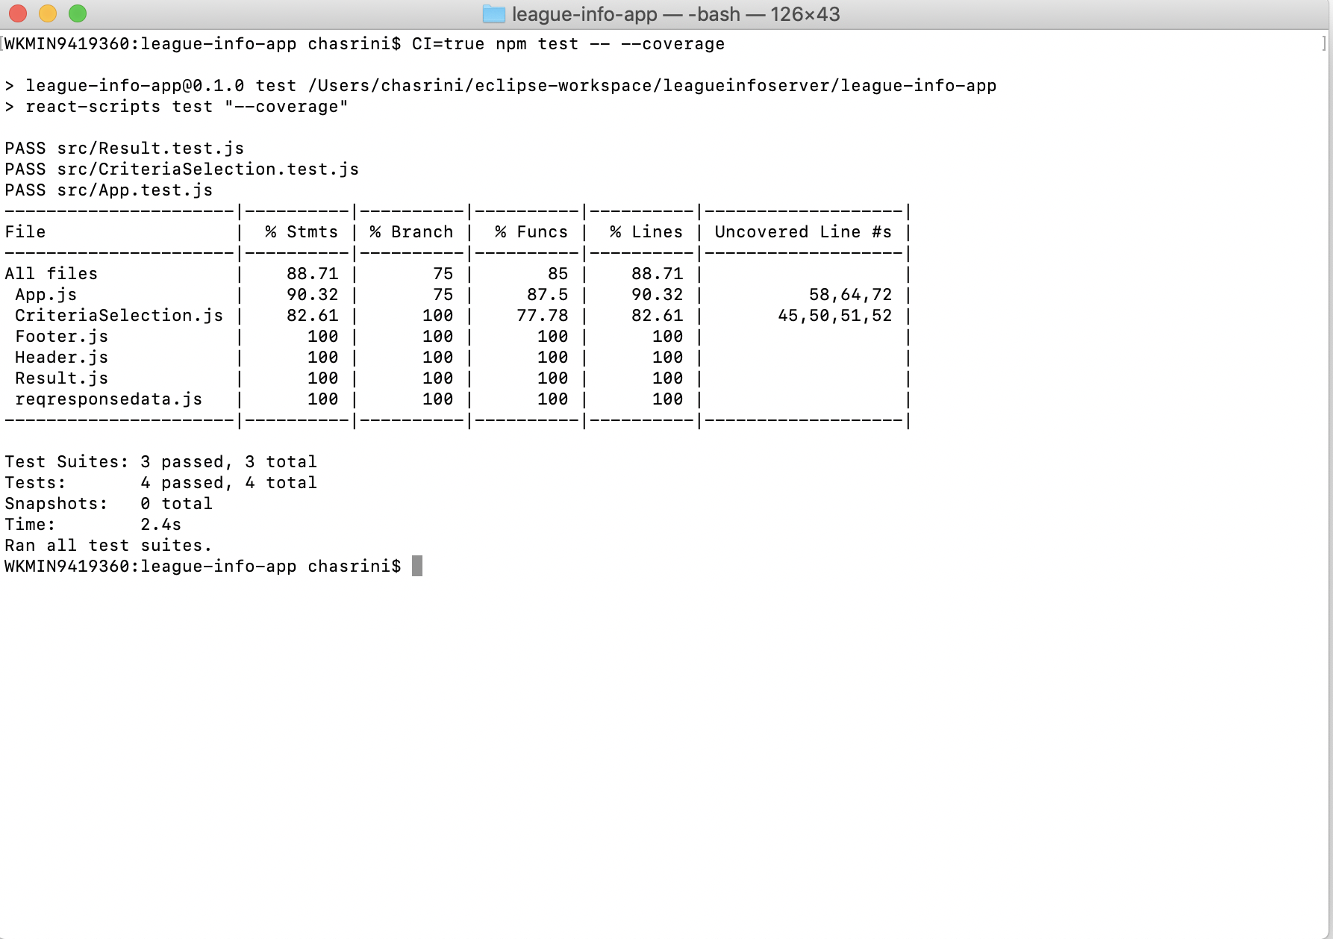

# UI Automated Testing - Selenium

You can execute the UI Automation testing from Jenkins Pipeline or using Maven Command or from Eclipse – to keep it simple, Jenkins UI has been shown below from where you can execute this test.

Tech stack Used: Selenium Java (Server Mode)

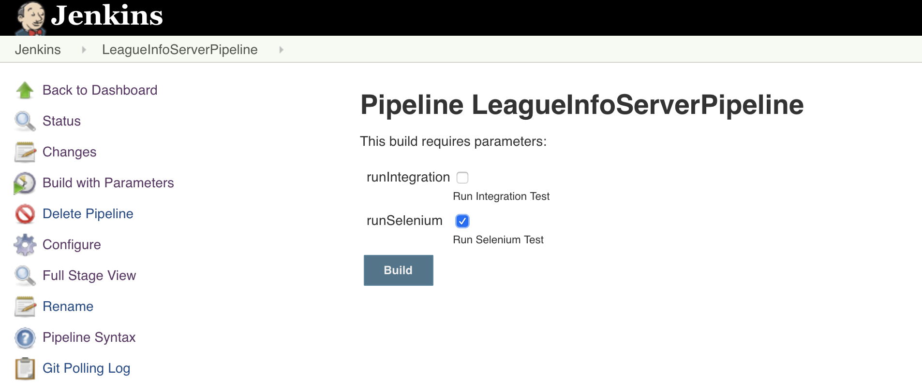

# Security Testing – ZA Proxy

Tech stack Used: ZA Proxy

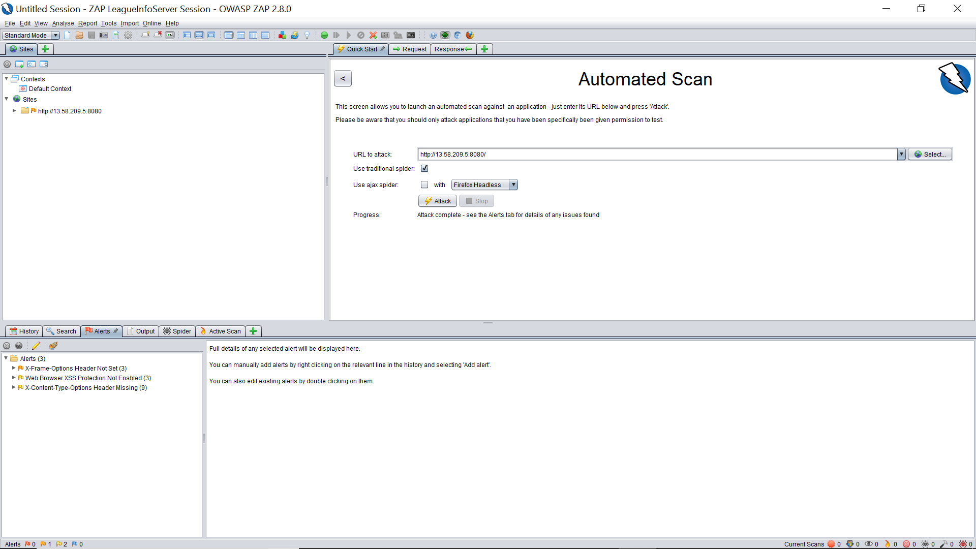

# Service Unit Testing – JUnit & Mockito

For running the unit testing for the Service – simply run the Jenkins build without checking any parameters

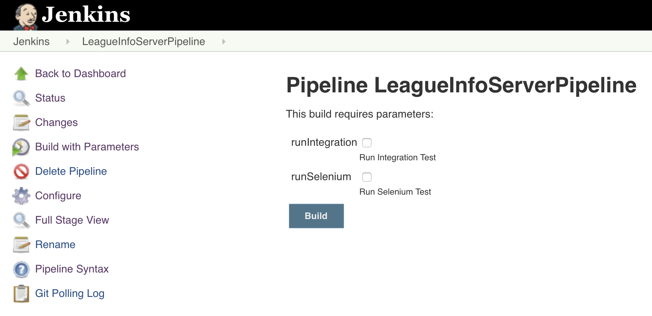

# Service Integration Testing - RESTAssured

For running the integration testing for the Service – simply check the integration test check box in the build

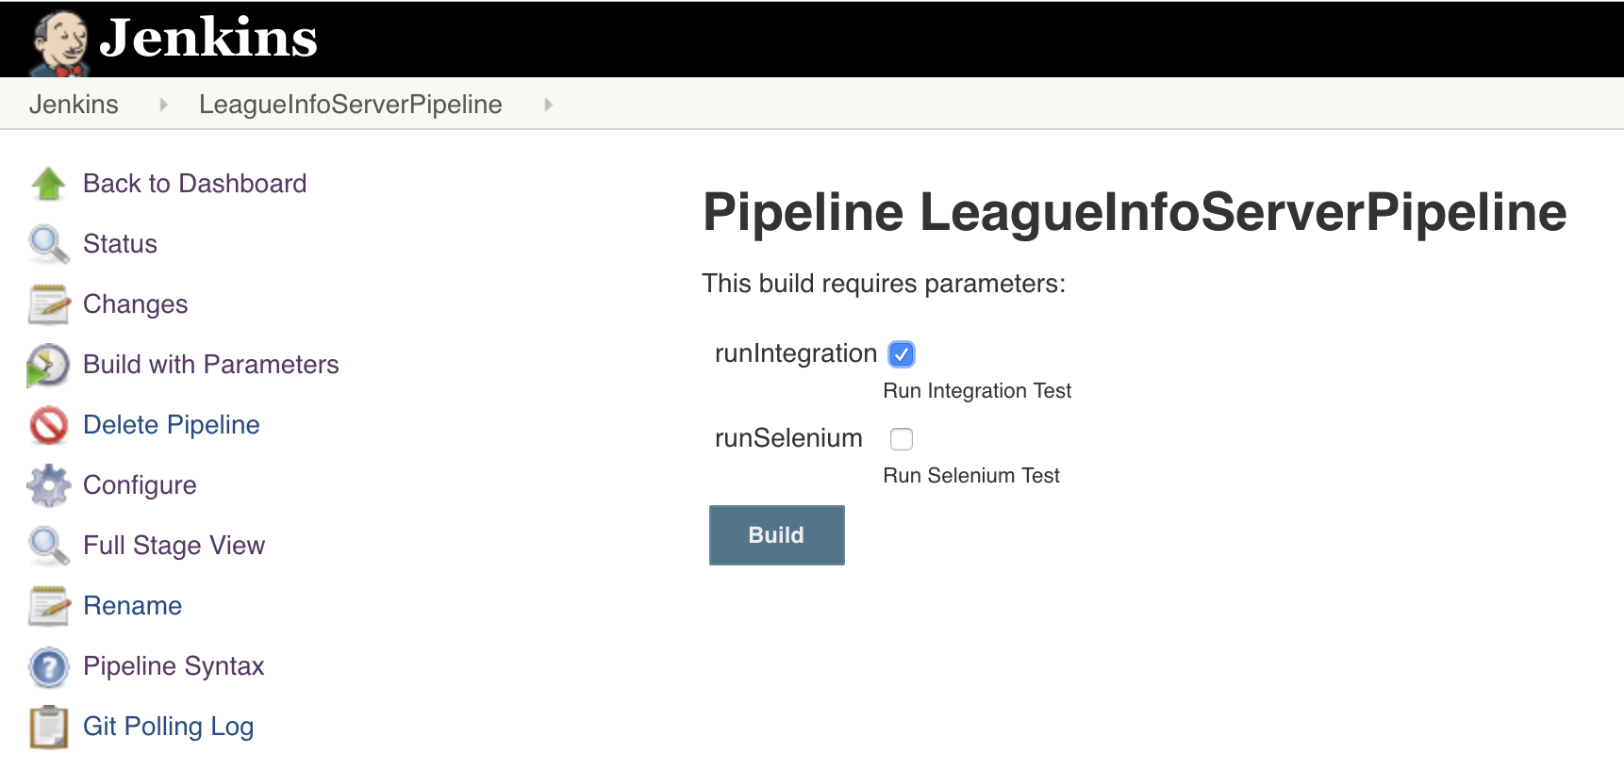

# API Performance Testing - JMeter

You can run the performance test by simply running the script file from the bin folder i.e. **bin/run-jmeter-api-test.sh**

Pre-requisite:

1. Install latest version of JMeter
2. Run the Services: bin/start.sh

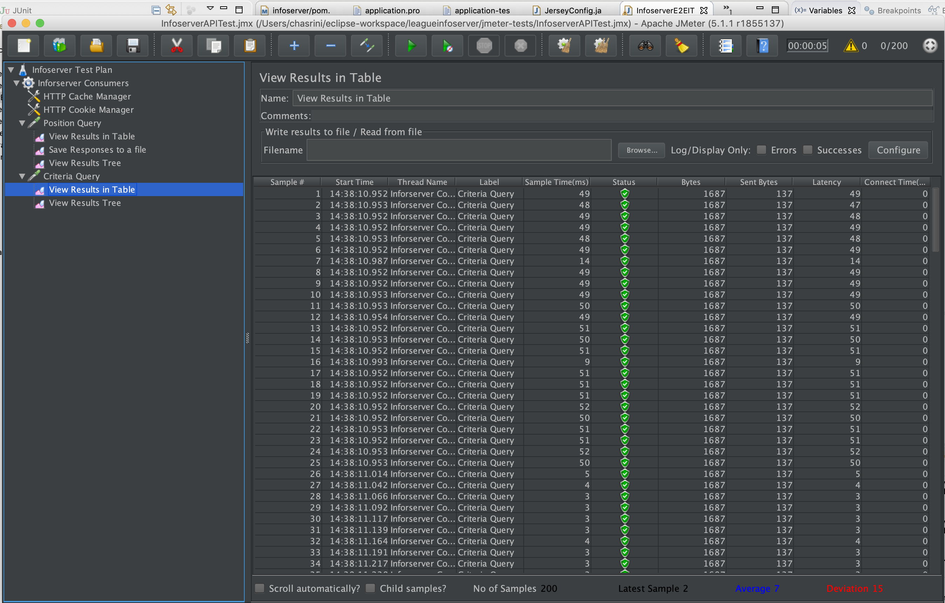

# Jenkins Pipeline Setup

Jenkins pipeline has been setup in Jenkins EC2 host provided

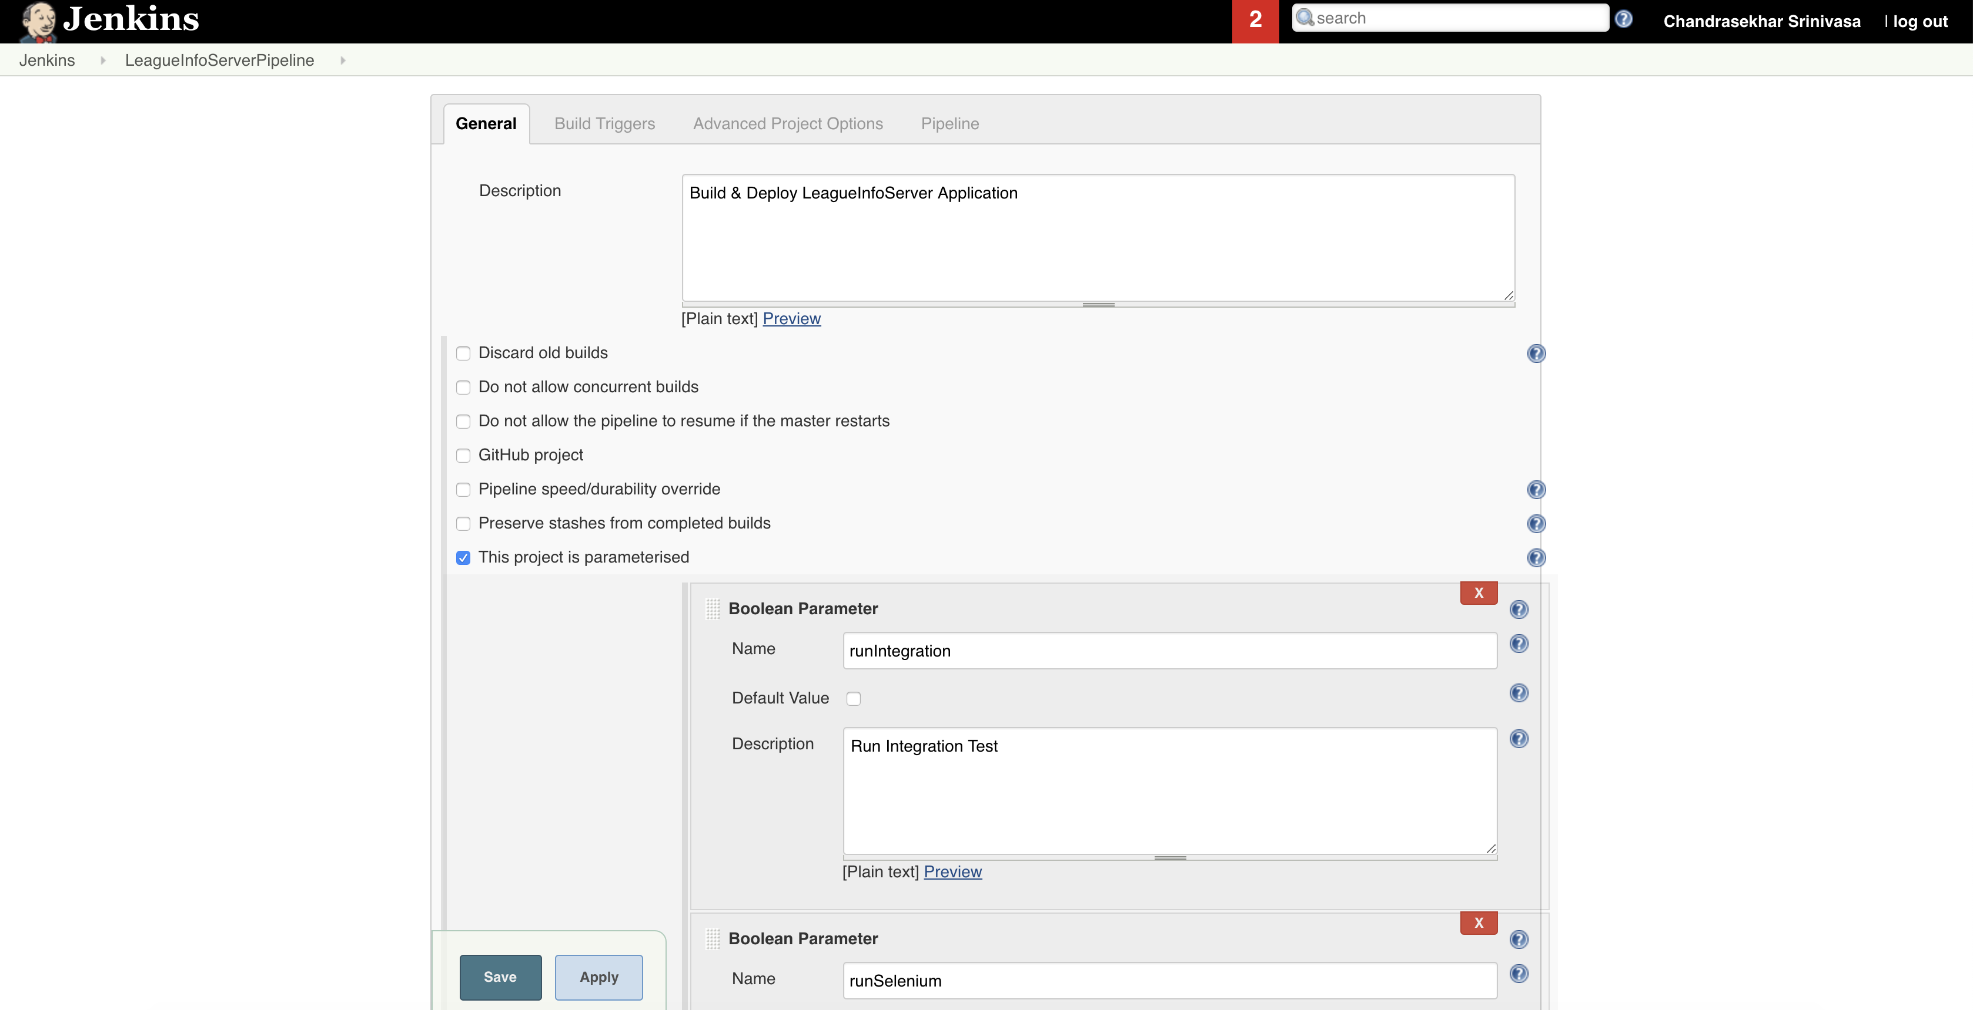

# Code Package Structure

drwxr-xr-x 4 chasrini LL\Domain Users 128 Aug 11 12:28 jenkins

drwxr-xr-x 3 chasrini LL\Domain Users 96 Aug 17 08:47 apache

drwxr-xr-x 13 chasrini LL\Domain Users 416 Aug 25 18:27 infoserver

drwxr-xr-x 18 chasrini LL\Domain Users 576 Aug 25 22:10 league-info-app

drwxr-xr-x 2 chasrini LL\Domain Users 64 Aug 25 22:14 logs

drwxr-xr-x 6 chasrini LL\Domain Users 192 Aug 30 14:28 jmeter-tests

drwxr-xr-x 6 chasrini LL\Domain Users 192 Aug 30 14:32 bin

drwxr-xr-x 6 chasrini LL\Domain Users 192 Aug 30 15:16 doc

|  |  |
| --- | --- |
| Jenkins | All the jenkin scripts will be available here within the scripts folder |
| Apache | Apache configuration for production – not required for local testing |
| Infoserver | API service Java code |
| League-info-app | UI code - react components |
| Jmeter-tests | Jmeter jmx file |
| Bin | Start, stop and status scripts and script to run jmeter |
| Doc | This document is available within this folder |

# Service Code Package Structure

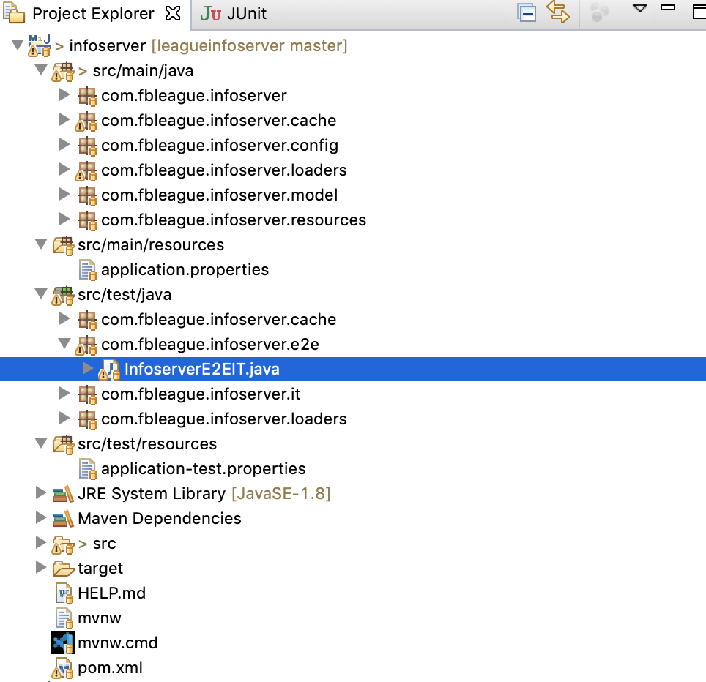

Tech Stack Used: Java, Spring Boot, Jersey, Maven, RESTAssured, tomcat, apache, Junit, Mockito, JMeter, Selenium, node.js, reactjs, Jenkins, Simulators/Emulators

# Deployment Structure

**ubuntu@ip-172-31-30-142**:**~/infoserver**$ ls -ltr

total 48864

-rwxr-xr-x 1 ubuntu ubuntu 374 Aug 18 16:31 **start.sh**

drwxrwxr-x 2 ubuntu ubuntu 4096 Aug 18 16:31 **logs**

-rwxr-xr-x 1 ubuntu ubuntu 545 Aug 18 16:38 **status.sh**

-rwxr-xr-x 1 ubuntu ubuntu 564 Aug 18 16:40 **stop.sh**

-rw-r--r-- 1 ubuntu ubuntu 50008310 Aug 25 13:04 **release.tar.gz**

drwxrwxr-x 3 ubuntu ubuntu 4096 Aug 25 13:06 **release**

**ubuntu@ip-172-31-30-142**:**~/infoserver**$ ls -ltr release/PROD/infoserver-1.0/

total 54148

-rw-r--r-- 1 ubuntu ubuntu 55440883 Aug 25 12:57 **infoserver-1.0.jar**

drwxr-xr-x 3 ubuntu ubuntu 4096 Aug 25 12:57 **build**